Yale Department of Chemistry
PHYSICAL CHEMISTRY SEMINAR

In Situ Probe of Structure and Dynamics at Metal electrode/Electrolyte Interface: Interfacial Field, Electro-induction Effect, and Hot Electron Transfer

Tim Lian
William Henry Emerson Professor of Chemistry, Emory

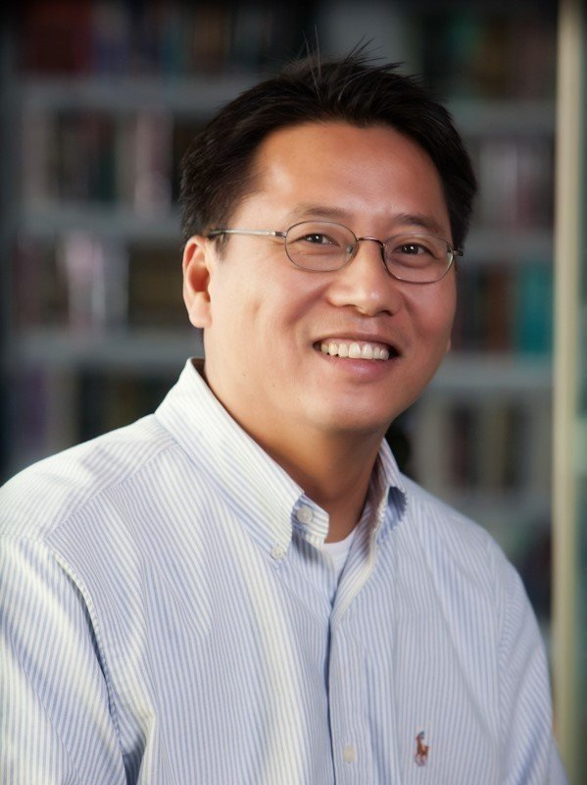

Friday, December 15, 2023 | Seminar 12 pm SCL 160
Lunch will be served

This seminar is generously sponsored by the Mrs. Hepsa Ely Silliman Memorial Fund

