Yale Department of Chemistry
INORGANIC CHEMISTRY SEMINAR

Fluorination on the Undergraduate Timescale: Reagent Development at a Primarily Undergraduate Institution (PUI)

Patrick Melvin
Assistant Professor of Chemistry,
Bryn Mawr College

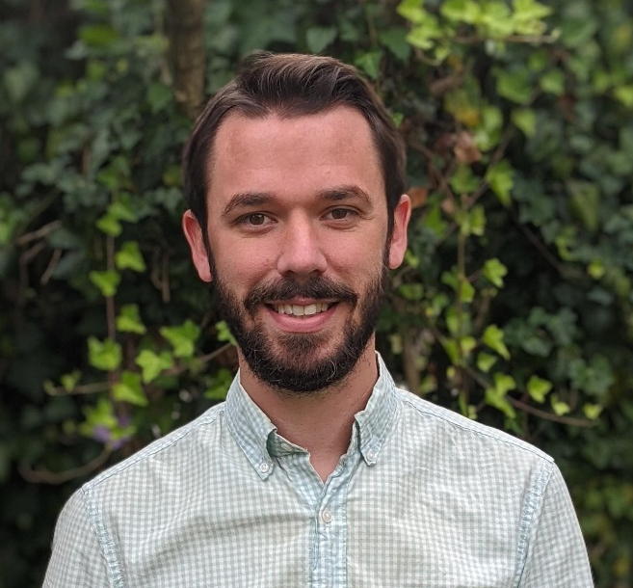

Monday, October 16, 2023
Seminar 12 pm SCL 160
Coffee Talk: 3pm SCL 111

This seminar is generously sponsored by the Mrs. Hepsa Ely Silliman Memorial Fund

