Yale Department of Chemistry
Seminar in Organic Chemistry

Single Atom Logic for Skeletal Editing

Mark Levin
Associate Professor, University of Chicago

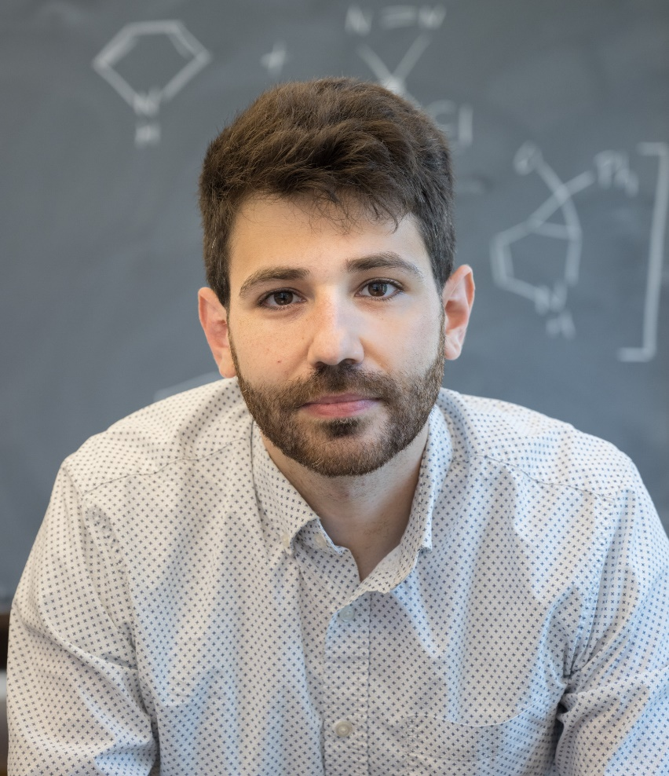

Wednesday, January 24, 2024
Student Research Talks - 3 pm SCL 111
Seminar - 4 pm SCL 160

This seminar is generously sponsored by the Mrs. Hepsa Ely Silliman Memorial Fund

