Yale Department of Chemistry
PHYSICAL CHEMISTRY SEMINAR

Unraveling the Vibrational Spectral Signatures and Ultrafast Dynamics of Strong H-bonds with Cryogenic Ion and 2D IR Spectroscopies

Joseph Fournier
Assistant Professor of Chemistry, Washington University in St. Louis

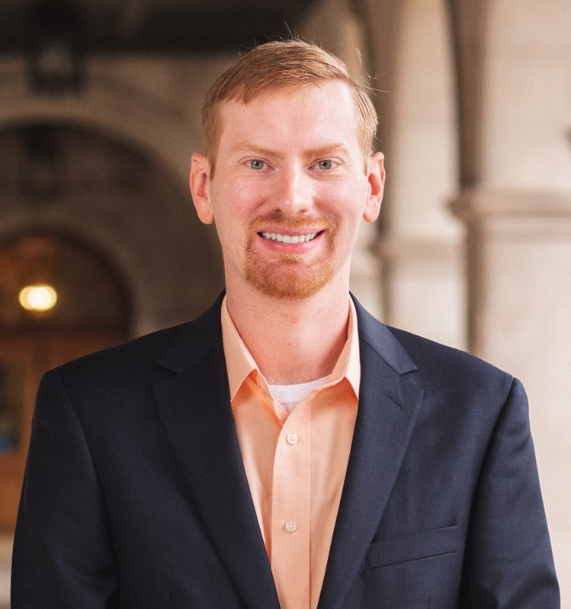

Tuesday, November 7, 2023
Seminar 4 pm SCL 160
Coffee Talk: 12pm CRB 102

This seminar is generously sponsored by the Mrs. Hepsa Ely Silliman Memorial Fund

